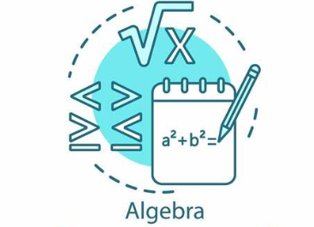
WEEK AT A GLANCE
August 6th to August 9th
TUESDAY: Syllabus and Edgenuity Requirements per course
- Login to Edgenuity
- Go over Course Expectations

WEDNESDAY: Edgenuity Coursework
- Login into Edgenuity
- Start Lessons
- Quizzes and Tests must be done in class and approved before taken

THURSDAY: Edgenuity Coursework
- Login into Edgenuity
- Start Lessons
- Quizzes and Tests must be done in class and approved before taken
FRIDAY:
Edgenuity Coursework
- Login into Edgenuity
- Start Lessons
- Quizzes and Tests must be done in class and approved before taken

